Running the Lions Project

# Introduction

The software will take a “by school” Excel spreadsheet and produce a “by sport” Excel spreadsheet. The software is designed to run from a terminal window, and it does not have a pretty interface.

# Start a Windows Powershell

* Use the Windows start bar to start a copy of the Windows PowerShell

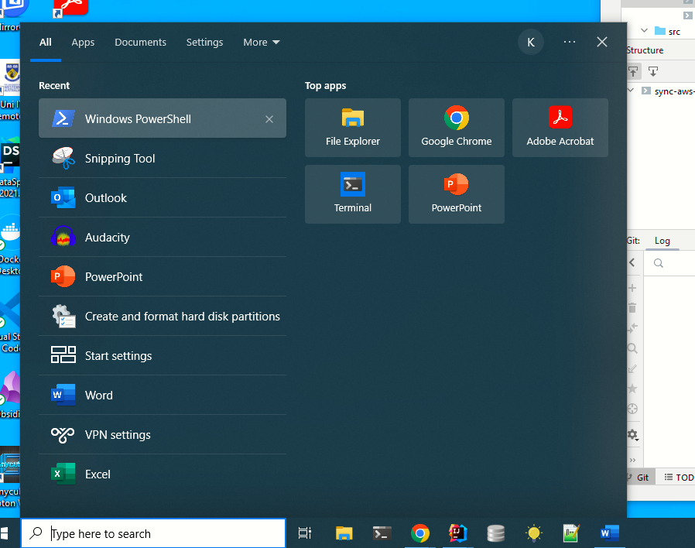

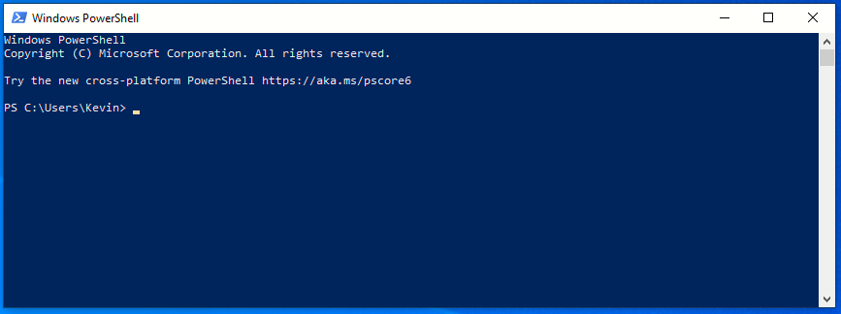

# Move to the correct directory

* Move to the directory where you unzip the .exe and .yaml file.

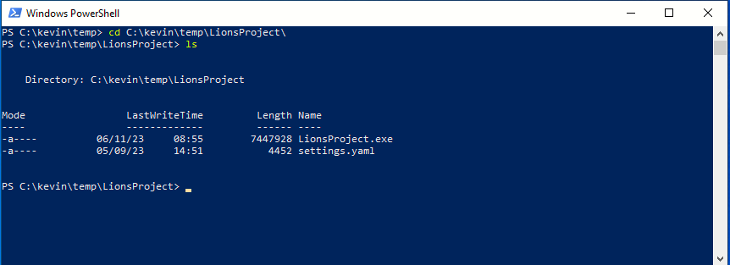

# Run the code

* Run the code. The arguments are:
  1. The path to the input file.
  2. The path to the output file. If this file exists, the software will attempt to modify this file[1]. If the file does not exist, a new file will be created. DO NOT USE a pre-existing “by school” file! Whoever made them left a look of dangling references, empty tabs, etc.
  3. The path to the settings.yaml file. This tells the software what tabs will be created, copied, etc.

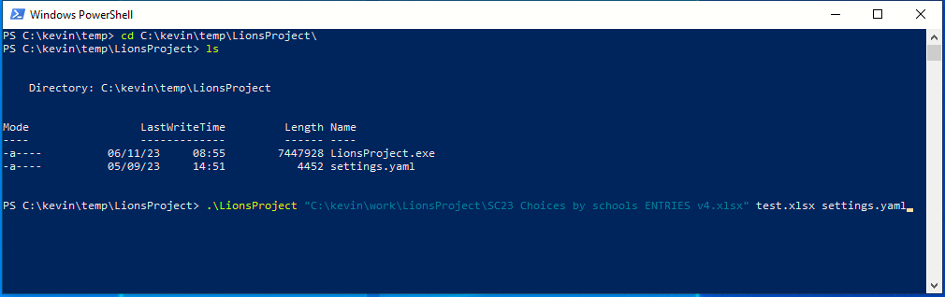

* A lot of logging will be seen.

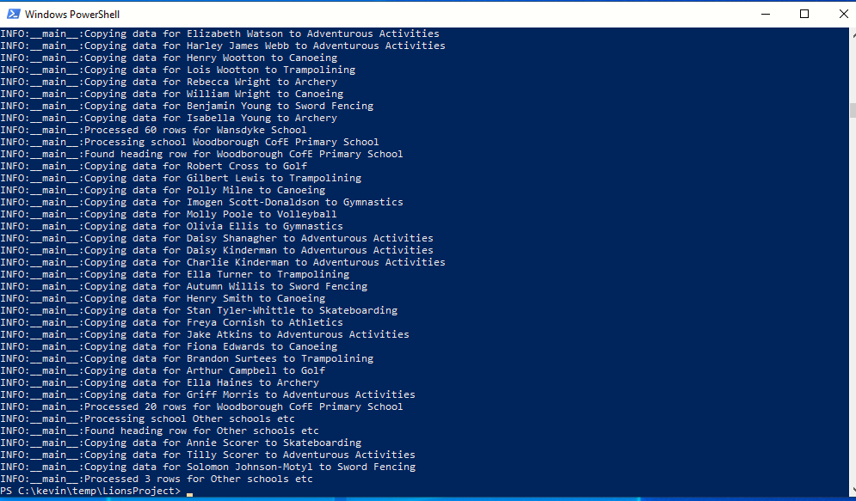

* The output file (test.xlsx) has the “by sport” data

# The settings.yaml

The settings.yaml file controls how the program works. It contains the schools, sports, and column references needed to move things around.

schools: this contains a list of the tabs representing the schools. If you have new schools in the “by schools” spreadsheet, you’ll need to add it here. The format is:

* name: the full school name.
* code: the code you assign to a school.
* tab: the name of the tab in the “by schools” spreadsheet.

sports: this contains a list of the sports to process. If you have a new sport, you’ll need to update this list. The format is:

* name: the name of the sport.
* tab: the tab's name in the “by sport” spreadsheet.
* school column: where in the “by school” spreadsheet, this column is read from.

by sport columns: this contains a list of the columns to be copied from the “by school” spreadsheet to the “by sports” spreadsheet. The format is :

* name: the name of the column.
* to: the column reference in the “by sport” spreadsheet that the data should be copied to.
* from: the column reference in the “by schools” spreadsheet that the data should be copied from. If this is missing, the software creates a blank cell in the to spreadsheet
* width: the width of the column in the “by sport” spreadsheet.

1. If the format of the output file is manually changed, the code is like to fail and make a mess of the file